**Bow Wave Identifier Template Work Instructions**

1 - Open Cobra; Run the below report - leave all filters as is (see screenshots below).

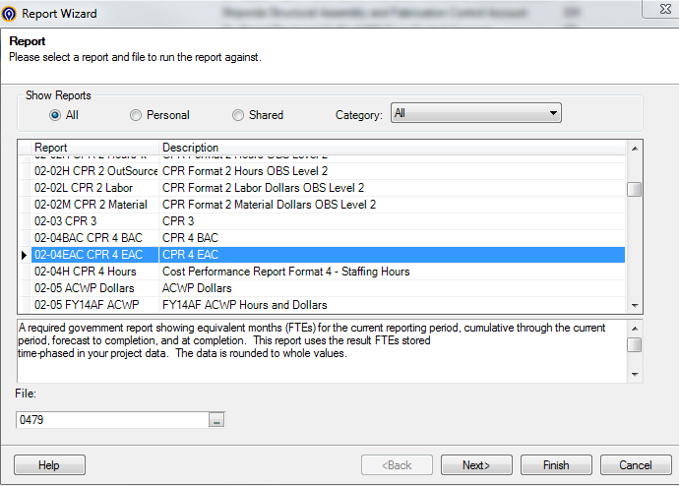

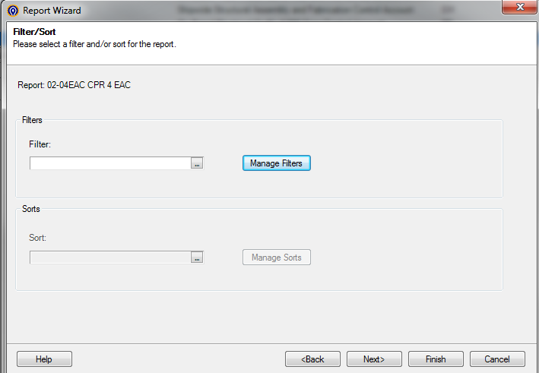

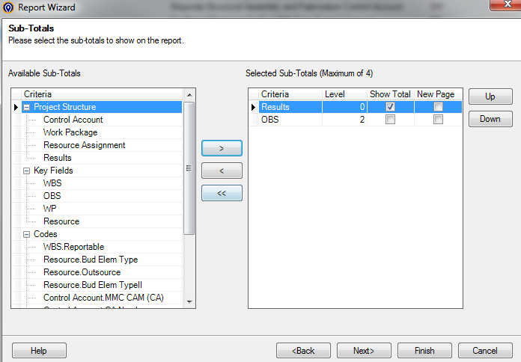

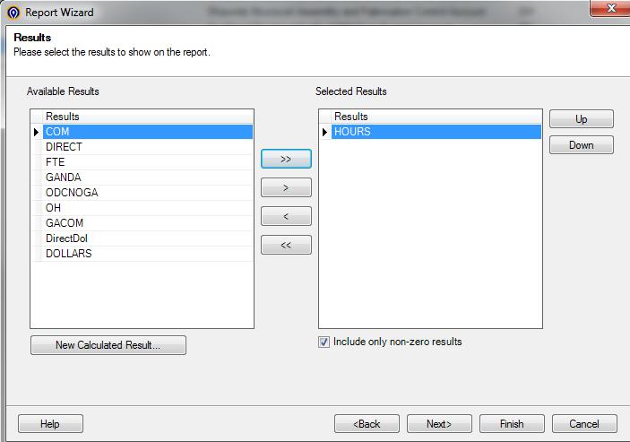

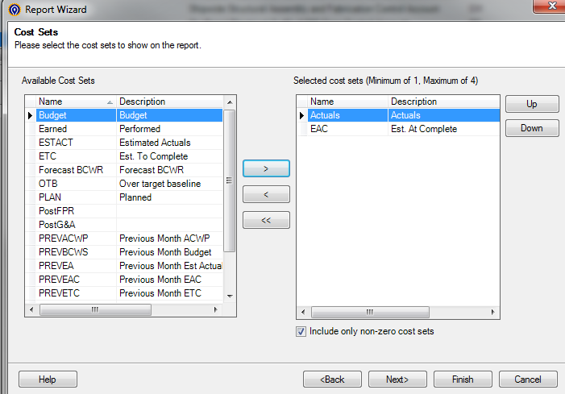

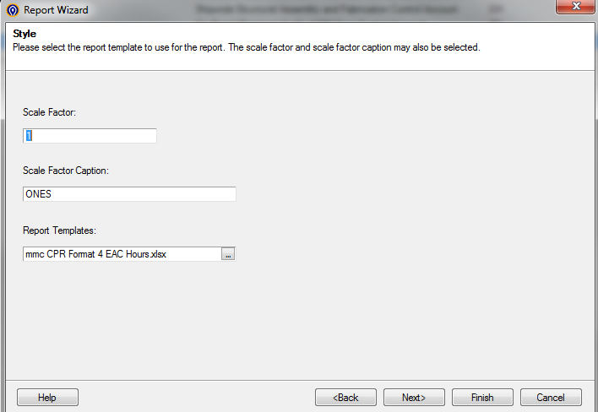

2 - Report will look like below when it is complete:



3 – Open Bow Wave Identifier Template from W: drive and save as the current processing month.

4 – Copy Cell S20 through S30 from ’02-04EAC CPR 4 EAC’ and paste regular into Cell T20 through T30. This will help identify the change from the previous month.

5 – Copy from Cell A7 to S7 through S30 on the excel document report that was just run out of Cobra (CPR 4 EAC).

6 – Paste into ‘02-04EAC CPR 4 EAC’ tab Cell A7 of the Bow Wave Identifier Template.